 | Year 12 Mathematics Essentials  Response (Test)  Measurement

Student Name:

Materials Allowed: | Pens, pencils, rulers, scientific (non-programmable) calculators, one single sided A4 page of notes
Time Allowed: | 55 minutes | Score: | /48
 |  | Percentage: | %

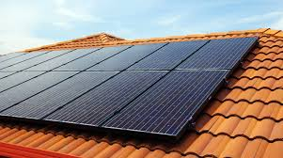
Not another bill! You have had it! The cost of power, water and fresh food is rising, and you want to do something about it. You decide to install solar panels on your roof, a new rainwater tank and some garden beds in which to grow fresh vegetables.
INSTALLING SOLAR PANELS
QUESTION 1 (11 marks)
Solar panels are installed using a modular design. Customers purchase multiple standard rectangular panels to meet their energy requirements. They can be installed in either a vertical or horizontal orientation (upright or on their side).
Scale of 1:10

- Determine the area of the standard rectangular solar panel in $m^{2}$
$$length=115cm=1.15m$$
$$width=63cm=0.63m$$
$$Area=l×w \\ =1.15×0.63 \\ =0.72m^{2}(to 2 d.p.)$$

Action | Marks
Measures side lengths correctly | 1
Applies scale correctly to determine dimensions | 1
Determines area of solar panel using $A=lw$ | 1
Applies conversion of length or Area (cm to m or cm² to m² | 1

(4 marks)
- Your north facing roof has a rectangular shape with the dimensions as given on the following diagram.

3.5 m

11 m

Determine the maximum number of panels that can fit on the roof. Justify your answer.
If placed horizontally
$$11÷1.15=9.56=9 panels$$
$$3.5÷0.63=5.56=5 panels$$
Therefore there are $9×5=45 panels possible$
If placed vertically
$$11÷0.63=17.46=17 panels$$
$$3.5÷1.15=3.04=3 panels$$
Therefore there are $17×3=51$panels possible. Therefore the maximum value is 51 panels.

Action | Marks
Determines number of panels that fit horizontally | 1
Determines number of panels that fit vertically | 1
Determines total number of panels by multiplying numbers | 1
Shows evidence of checking both possible orientations | 1
Selects the maximum value | 1

(5 marks)
- If each panel costs $435, and installation costs $650, determine the total cost for the installation and supply of the solar panels.
$$51×\$435+650=\$22 835$$

Action | Marks
Calculates the cost of solar panels by multiplying number of panels by $435 | 1
Adds the cost of installation to determine final cost. | 1

(2 marks)
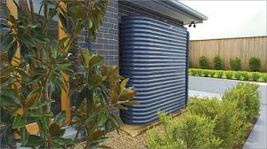
PURCHASING A RAINWATER TANK

QUESTION 2 (20 marks)
You have two options for purchasing a rainwater tank. One is an innovative triangular design that fits into the corner between two walls. The other is the modern rainwater tank design that fits closely to the house and is cheap to build.
[INSERT PICURES OF DESIGNS HERE – ONE TRIANGULAR PRISM (cm), THE OTHER A COMPOSITE SHAPE OF A RECTANGULAR PRISM WITH SEMI-CIRCULAR ENDS (m))

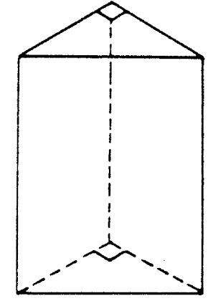
80 cm
90 cm
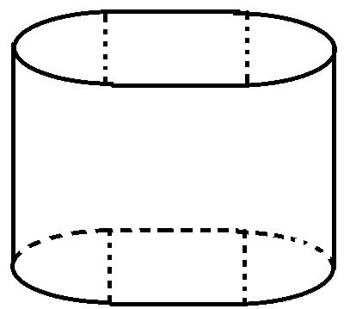
0.4 m

1.0 m
150 cm

1.2 m

TRIANGULAR DESIGN | MODERN DESIGN

- Determine the volume of the triangular design in $m^{3}$
$$V=\frac{1}{2}bhl=\frac{1}{2}×80×90×150=540 000cm^{3}$$
$$540 000cm^{3}÷1 000 000=0.54m^{3}$$

Action | Marks
Identifies volume expression as $V=\frac{1}{2}bhl$ | 1
Correctly calculates the volume of the shae | 1
Applies conversion so answer is in $m^{3}$ | 1

(3 marks)
- Determine the volume of the modern design in $m^{3}$.
$$V=πr^{2}+bwl \\ =π×{0.2}^{2}×1+1.2×0.4×1 \\ =0.126+0.48 \\ =0.61m^{3}$$

Action | Marks
Determines radius as half of diameter | 1
Identifies shape as compound shape of cylinder and rectangular prism | 1
Correctly substitutes values into $V=πr^{2}l$ for volume of cylinder | 1
Correctly substitutes values into $V=bwl$ for volume of prism | 1
Correctly calculates individual volumes | 1
Adds volumes of shapes to determine final volume | 1

(6 marks)
You decide to opt for the modern design as it is cheaper and will fit alongside your house.
- Determine the capacity of the modern design in litres (L)
$$0.61×1000=610L$$
Action | Marks
Applies conversion of $1000L=1m^{3}$ correctly | 1

(1 mark)
- You wish to have your rainwater tank painted. Determine the surface area of the tank.
$$A\left(rectangular side\right)=1.2×1=1.2m^{2} \\ A\left(top\right)=πr^{2}+lw \\ =π×{0.2}^{2}+0.4×1.2 \\ =0.61m^{2} \\ l\left(curve\right)=\frac{1}{2}\left(circumference\right) \\ =πr \\ =π×0.2 \\ =0.628m$$ | $$A\left(side\right)=0.628×1 \\ =0.628m^{2} \\ Total surface area=\left(2×1.2\right)+\left(2×0.61\right)+\left(2×0.628\right) \\ =4.876 m^{2}$$

Action | Marks
Determines area of rectangular side panel | 1
Identifies area of composite top panel as circle and rectangle | 1
Calculates area of composite top panel | 1
Determines length of semicircular arc using half of circumference ($πr$) | 1
Calculates area of side panel | 1
Determines total surface area by adding areas of all sides | 1

(6 marks)
- If it costs $20.99 for one tin of paint (each tin is 2L), and one litre can cover 1.5$m^{2}$, determine the cost of paint required to paint the tank if three coats of paint are required.
$$Total area required=3×4.876 \\ =14.628m^{2} \\ Litres required=14.628÷1.5 \\ =9.572L \\ Number of tins=9.752÷2 \\ =5 tins \\ Cost of paint=5×20.99 \\ =104.95$$

Action | Marks
Determines area of painting required for three coats | 1
Determines number of litres required by dividing by coverage area | 1
Determines the number of tins of paint required | 1
Determines cost of paint | 1

(4 marks)

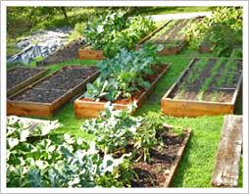
BUILDING A RAISED GARDEN BED

QUESTION 3 (17 marks)
You wish to buy a pre-made raised garden bed, but you do not like the look of the wood or metal designs. You find a ceramic option which comes in a trapezium prism design. A three-dimensional view is shown below.
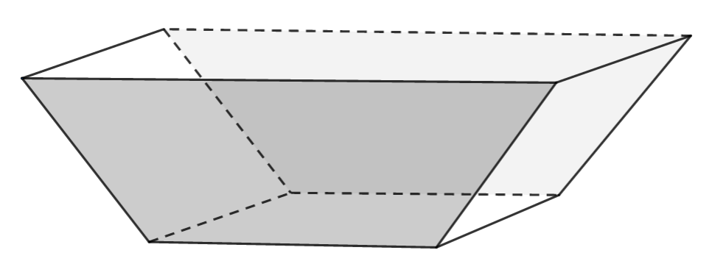
70 cm
170 cm

47.7 cm
50cm

70 cm
140 cm

- Draw a scale diagram of the side view showing the trapezium face of the garden bed. Use the scale 12.5:1

Action | Marks
Applies scale to determine side lengths | 2
Draws the scale diagram accurately and neatly | 2

(4 marks)
- The inside of the garden bed will be lined with thick, black plastic sheeting to protect the ceramic from acids in the soils. Determine the total area of black plastic sheeting in $cm^{2}$ required if the bottom and four sides need to be covered completely.
$$A\left(trapesium\right)=\frac{140+170}{2}×47.7 \\ =7393.5cm^{2} \\ A\left(rectangular side\right)=50×70 \\ =3500 cm^{2}n \\ A\left(rectangular base\right)=70×140 \\ =9800 cm^{2}$$ | $$Total surface area=\left(2×7393.5\right)+\left(2×3500\right)+9800 \\ =31 587cm^{2}$$

Action | Marks
Determines area of trapezium side | 1
Determines area of rectangular side | 1
Determines area of rectangular base | 1
Adds area of each side to determine total surface area. | 1

(4 marks)
- The manufacturer stated that the volume of the garden bed is 518 L. What is wrong with their statement?
Action | Marks
States that units of volume are $m^{3}$ or litres are units of capacity. | 1

(1 mark)
- The garden bed will be filled with soil so that it is 90% full. Determine the volume of soil required in $cm^{3}$.
$$V\left(trapzium\right)=A\left(trapezium\right)×length$$
$$=\frac{140+170}{2}×47.7$$
$$=7393.5$$
$$V\left(90\% full\right)=\frac{90}{100}×7393.5$$
$$=6654.15cm^{3}$$

Action | Marks
Substitutes correctly into trapezium volume formula $V=\frac{a+b}{2}hl$ | 1
Calculates volume of whole shape correctly | 1
Applies percentage to solve for filled volume | 1

(3 marks)
- You wish to place some vegetable seedlings into the now filled garden bed. On the punnet of seedlings, the instructions tell you that each seedling must be planted so that they are 10cm from each other seedling and 10cm from the edge of the garden bed. Determine the number of seedlings that can be planted in the garden bed. Justify your answer. (A top-down view of the garden bed at the soil level is shown below to help you)
1670 mm

$$seedlings long=\left(1670-200\right)÷10=14.7$$
$$seedlings wide=\left(700-200\right)÷10=5$$
.Therefore there can be 14 seedlings by 5 seedlings which gives 70 seedlings in total ($5× 14$)

700 mm

Action | Marks
Demonstrates evidence that plants are not within 10cm of the edge and other plants | 1
Determines maximum number of plants possible in horizontal and vertical directions | 1
Multiplies numbers together to get total number of plants | 1
 | 1

(3 marks)
- You wish to connect piping to provide water to the plants. Using the diagram above, determine the length of piping required (in metres) if the pipes are placed against the edges of the garden bed.
$$P=1670+700+1670+700 \\ =4740mm \\ =4.74m$$

Action | Marks
Applies conversion from mm to m | 1
Determines perimeter of the garden bed | 1

(2 marks)

